* Resource group has virtual machines and other things related to it after creation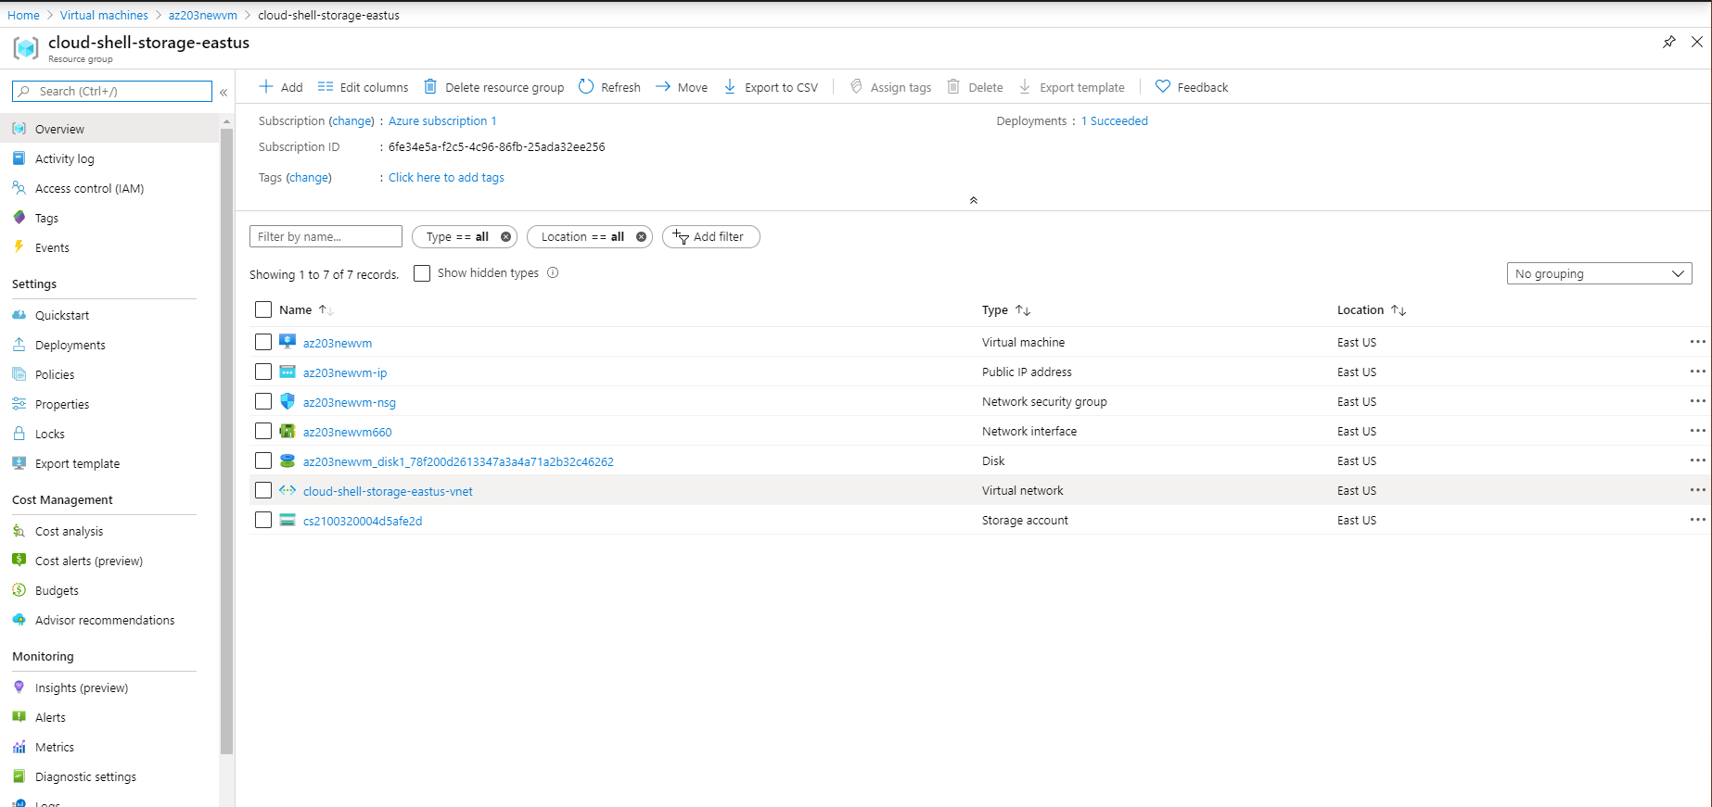
* Save the Ip address with a valid domain name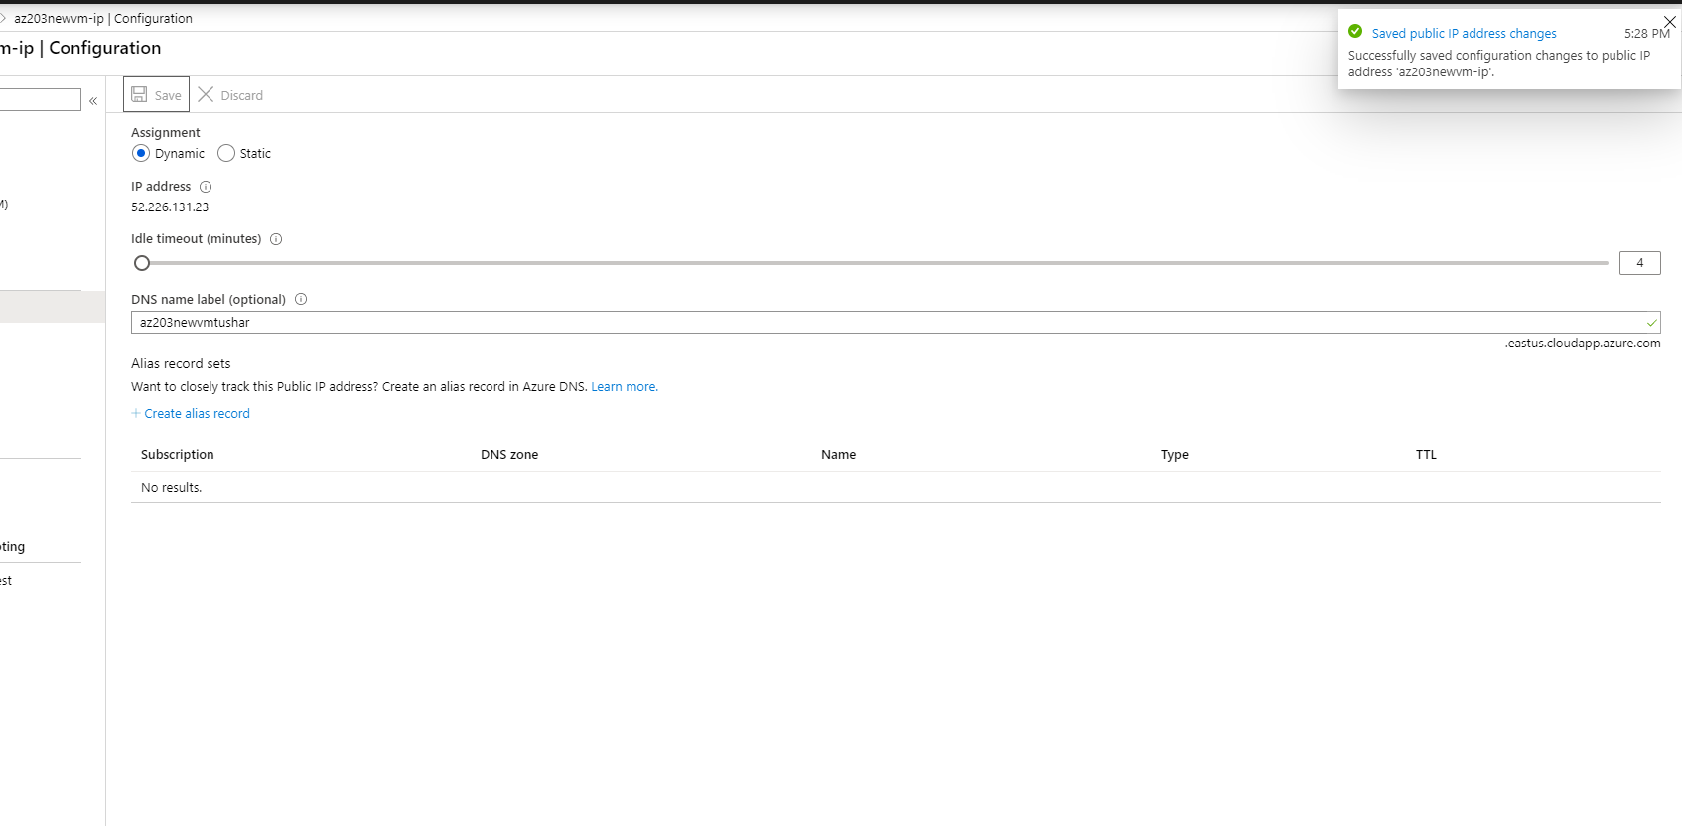
* Connect to a virtual Machine with Public IP address on port 3389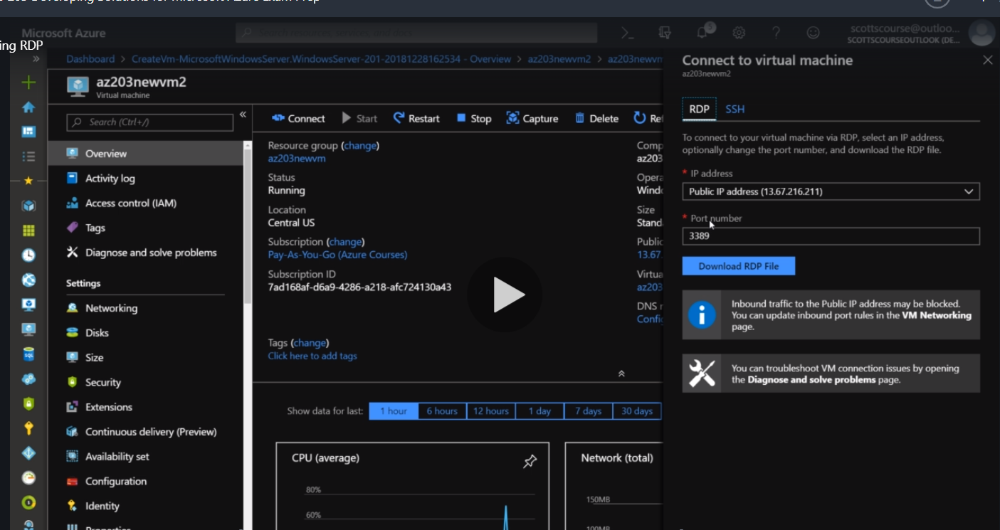
* Download the RDP file and enter the user name and password for the machine to login. 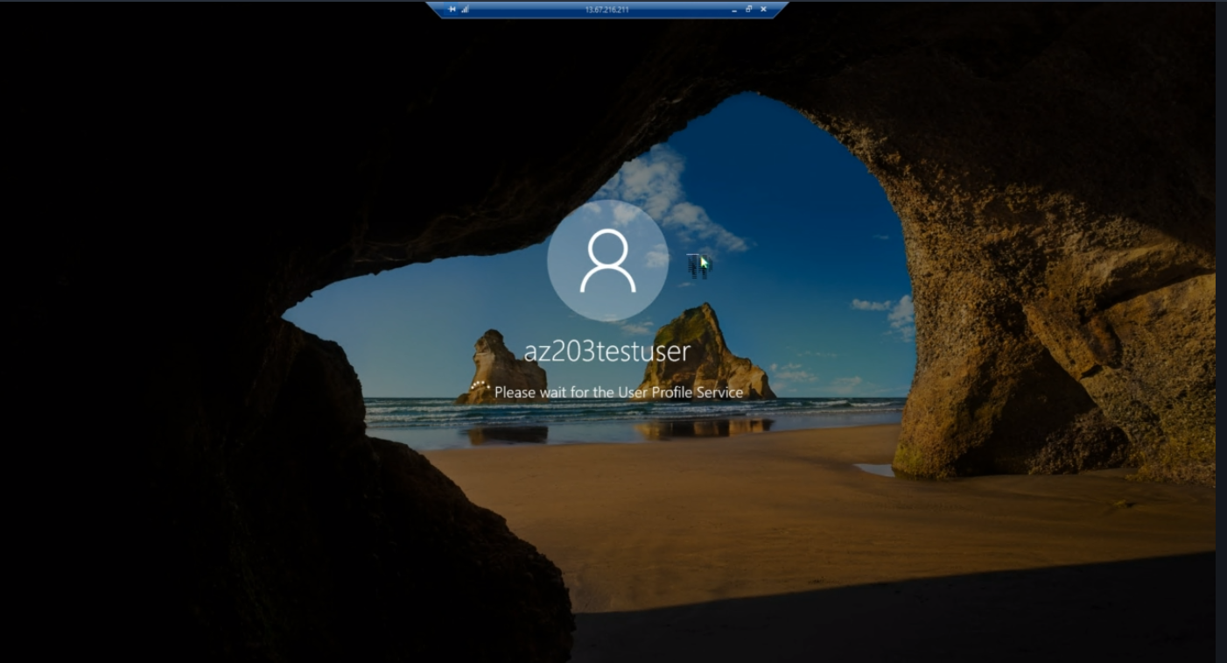

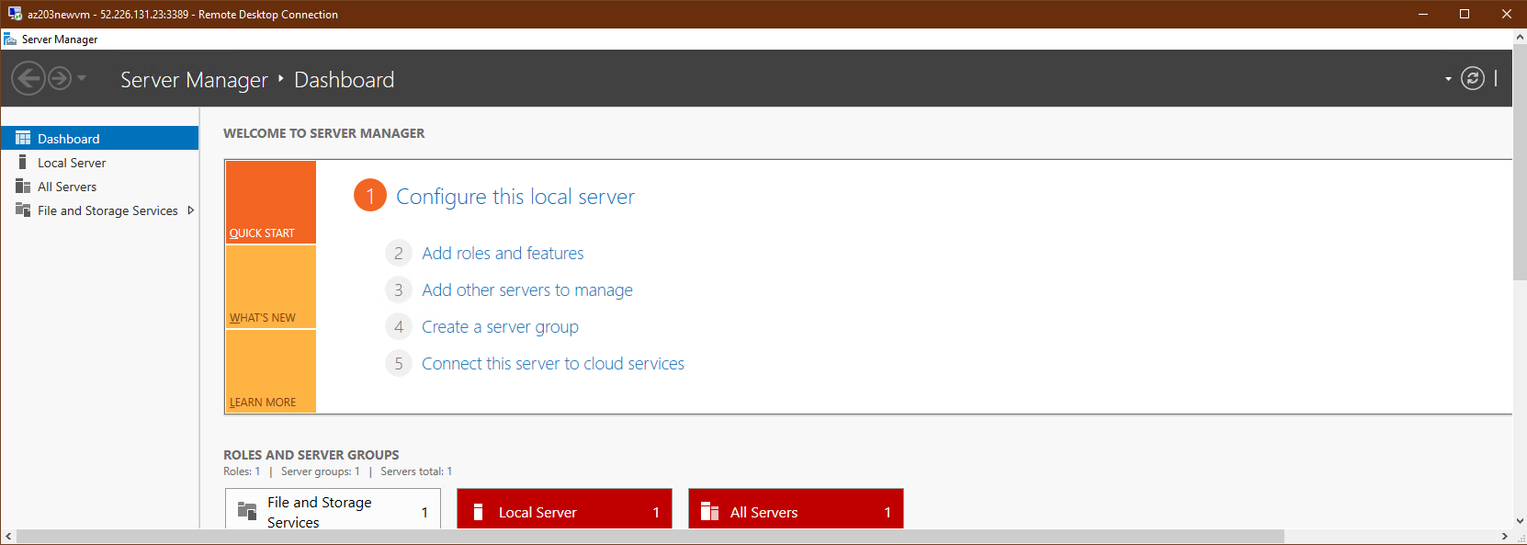

* If RDP is not working that could be a firewall issue try restarting it first or try these two.

-One can be in subnet

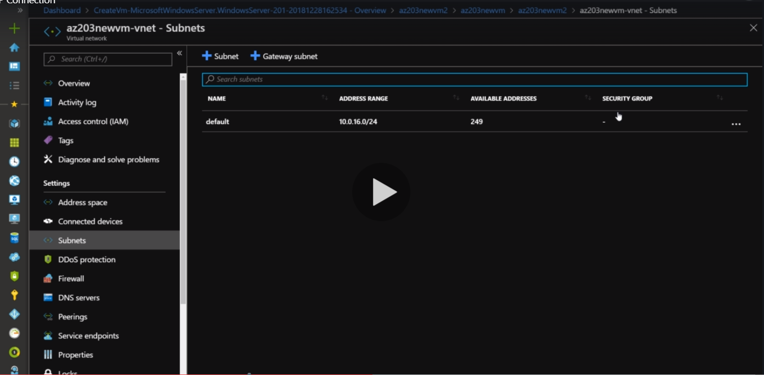

-One can be on network tab then we go there we can check if RDP access to the machine (port 3389 is inbound if not add it with Add Inbound port rule button)is enabled if not then error will be there while connecting to machine.

